**Robot Arm**

UNDER THE SUPERVISION OF PROF. KHALED YOUSEF

**ROBOTIC ARM PROJECT**

Students' Names:

* جهاد مؤمن محمود
* علياء محمد عبد الفتاح
* ندى هشام عبد الجابر
* منة الله محمد محمود علي
* أحمد ممدوح
* أحمد محمد رمضان
* عبد الرحمن هشام
* أدهم إيهاب
* أسامة جبريل
* يوسف مطاوع

Objective:

The Arm robot holds a cube with gripper and places it in a cup.

A-Structure:

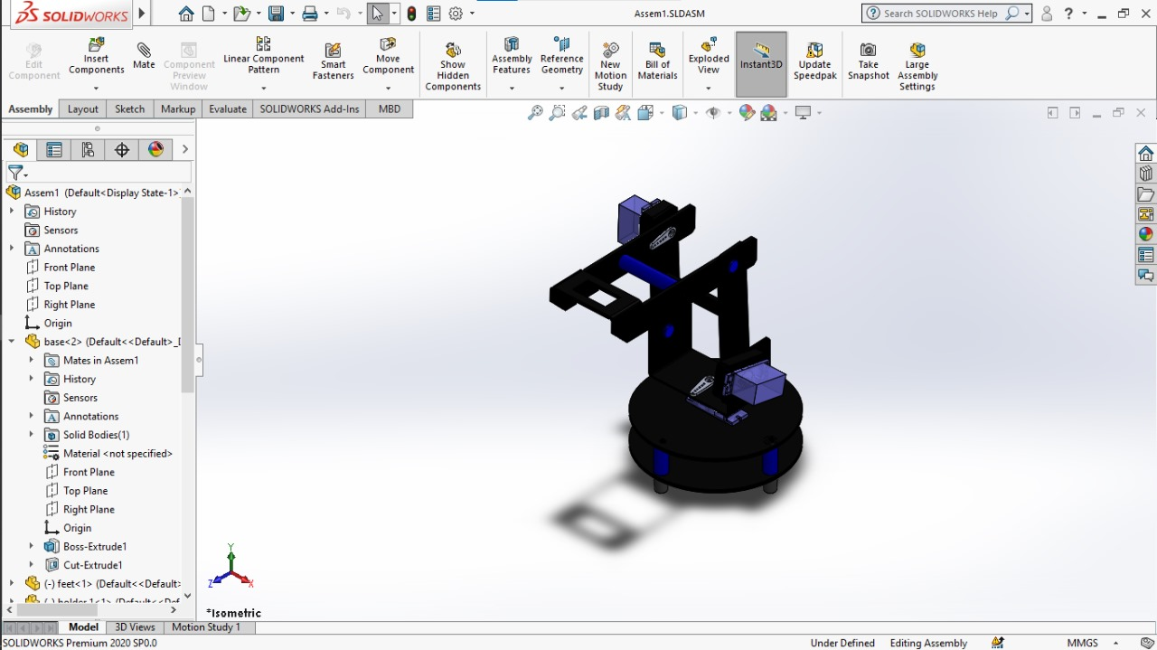Using SolidWorks we designed the robot arm with gripper at the end.

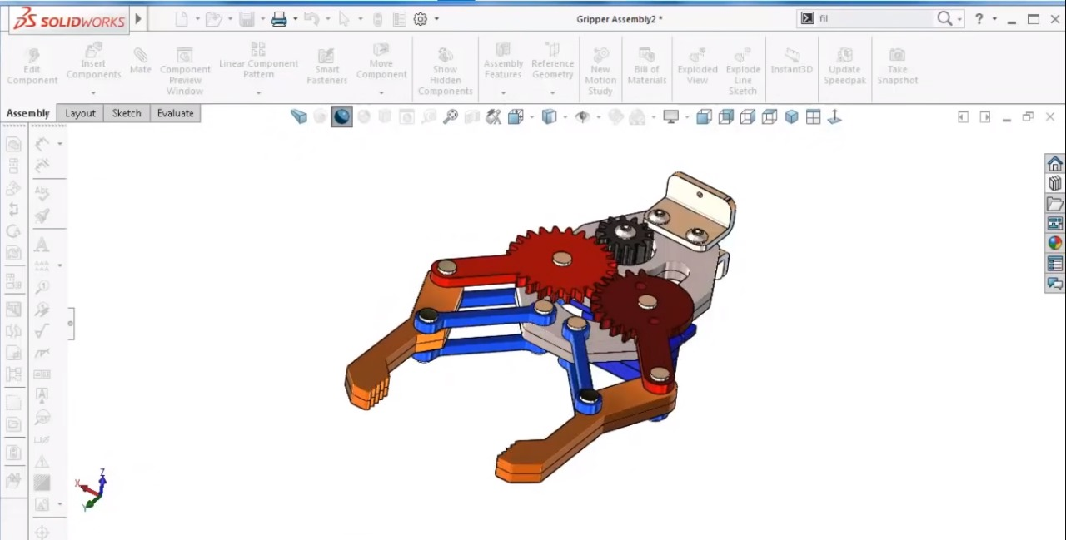

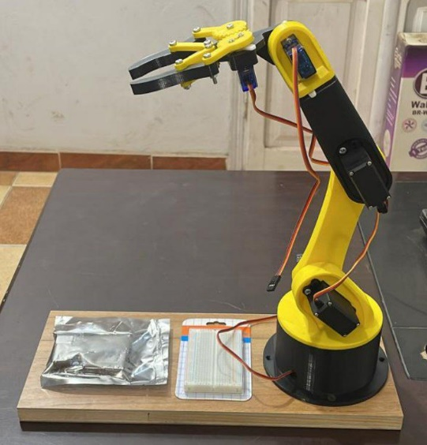**Design already used:**

Link 1

Gripper

Link 2

Joint2(Mg995 180°)

- Operating voltage: 4.8 V to 7.2 V.

Weight: 55 g

Joint1(MG996 180°)  
- Operating voltage: 4.8 V to 7.2 V.

Weight: 55 g

Structure analysis of the robot and the needed torque at every point of action Our robot's size is 200 gram we imagined to be equally distributed over the whole robot length (46.5 cm ) and we used 6 servos each with a mass of 55 gram and a downward force of 0.53 newton due to gravity The following table shows the torque in N.cm needed at every point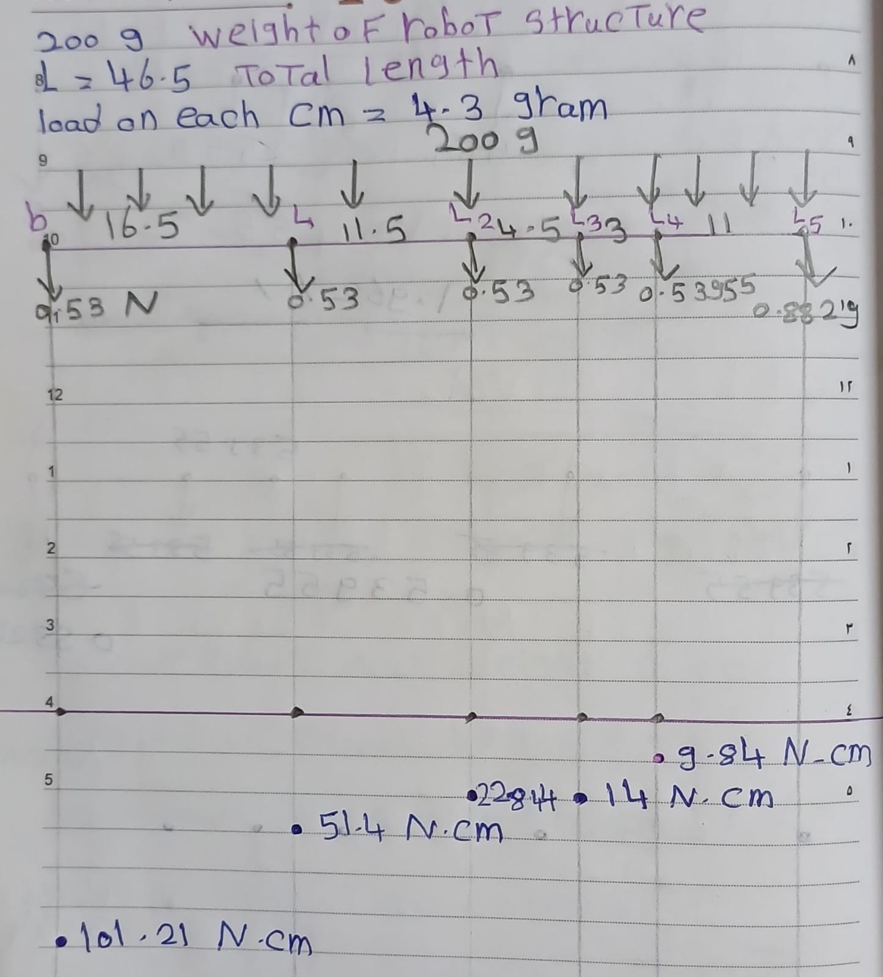

B-Kinematics:

From Lecturer's Slides:

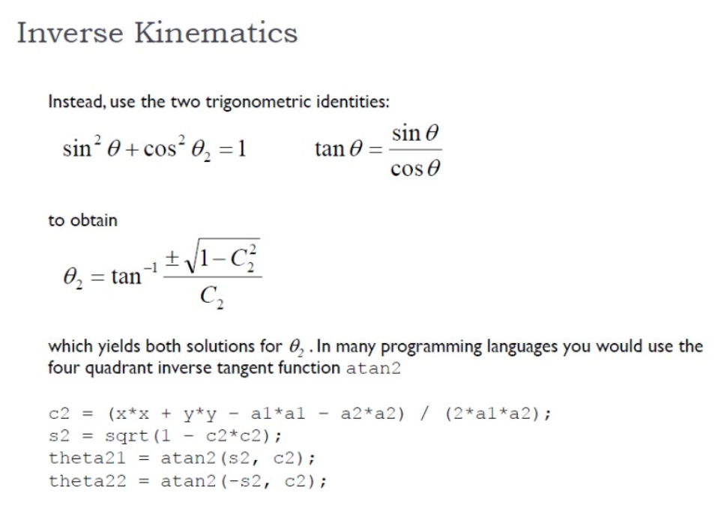

By trigonometry:

C-Coding:

D-Tools:

-Arduino Uno

-Servo Motor mg996r 360

-Servo Motor mg996r 180

-Servo Motor SG90 180

-Ultra sonic HC-SR04

-H_bridge

